Fenn’s Old Works Feasibility Study Survey
Name:
Email/tel :
Address :
Date :
Following a meeting on 15th February 2017 between Natural England, Natural Resources Wales, Cadw and Shropshire Wildlife Trust, a vision statement was agreed that states:
“Fenn’s Old Works is conserved in situ, providing an unmanned, integrated interpretative facility and viewing platform for the Fenn’s, Whixall and Bettisfield Mosses, accessible to all, with the local community actively engaged in its conservation and operation. Maintenance and operation of this facility will be low burden and self-sustaining.”

Have you visited Fenn’s Whixall and Bettisfield Mosses National Nature Reserve in the last 2 years? | Yes | No
Are you broadly in support of this vision statement? | Yes | No
Do you know that the Works is legally protected as a Scheduled Monument and Grade II* listed structure? | Yes | No
Are you aware that the Works is thought to be the only one of its type surviving today? | Yes | No

A recent application for funds towards a Feasibility Study has been successful. The Study includes a ground-based and aerial photogrammetry survey of Fenn’s Old Works to create a 3D model providing a record of its current state and exploring how the Works may look, when conserved. Informed by this model, a full structural survey will also be carried out, together with a community consultation exercise.
The following questions seek to find out whether there is support for the potential to conserve Fenn’s Old Works; and to consider how the Works could be developed as an unmanned facility to interpret the story of the Mosses and past peat extraction for locals, visitors and education purposes.
Future applications for funding will reflect whether support exists and will scrutinise the financial implications of the conservation/ interpretation elements and the ultimate sustainability of such a facility. Bringing benefit to the local community and adding value to the visitor experience within rural Wrexham/ Shropshire will be core outputs for such an application.
There is an Open Meeting taking place on Tuesday 13th March 2018 at 6pm at Bettisfield Village Hall. At that meeting there will be an update on the technical surveys of the Fenn’s Old Works and an opportunity to ask questions about the Study.

Question | Yes | No | Not Interested | Disagree Strongly
Are you broadly in support of the Feasibility Study and what it seeks to do?
Please expand on the reasons for your answer:
Question | Yes | No | Not Interested | Disagree Strongly
Would you support a further application for funds to develop plans for the conservation of Fenn’s Old Works?
If YES, why?

Question | Yes | No | Not Interested | Disagree Strongly
Do you think the local community should be fully involved in any further application?
If YES, how?

Question | Yes | No | Not Interested | Disagree Strongly
Do you think the local community could directly benefit from the conservation/ interpretation of Fenn’s Old Works?
e.g. voluntary involvement, educational involvement, interest groups
If YES, how?

Question | Yes | No | Not Interested | Disagree Strongly
Do you think the visitor economy could directly benefit from the conservation/ interpretation of Fen’s Old Works?
Please expand on the reasons for your answer:

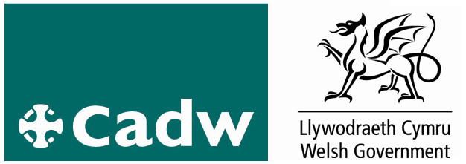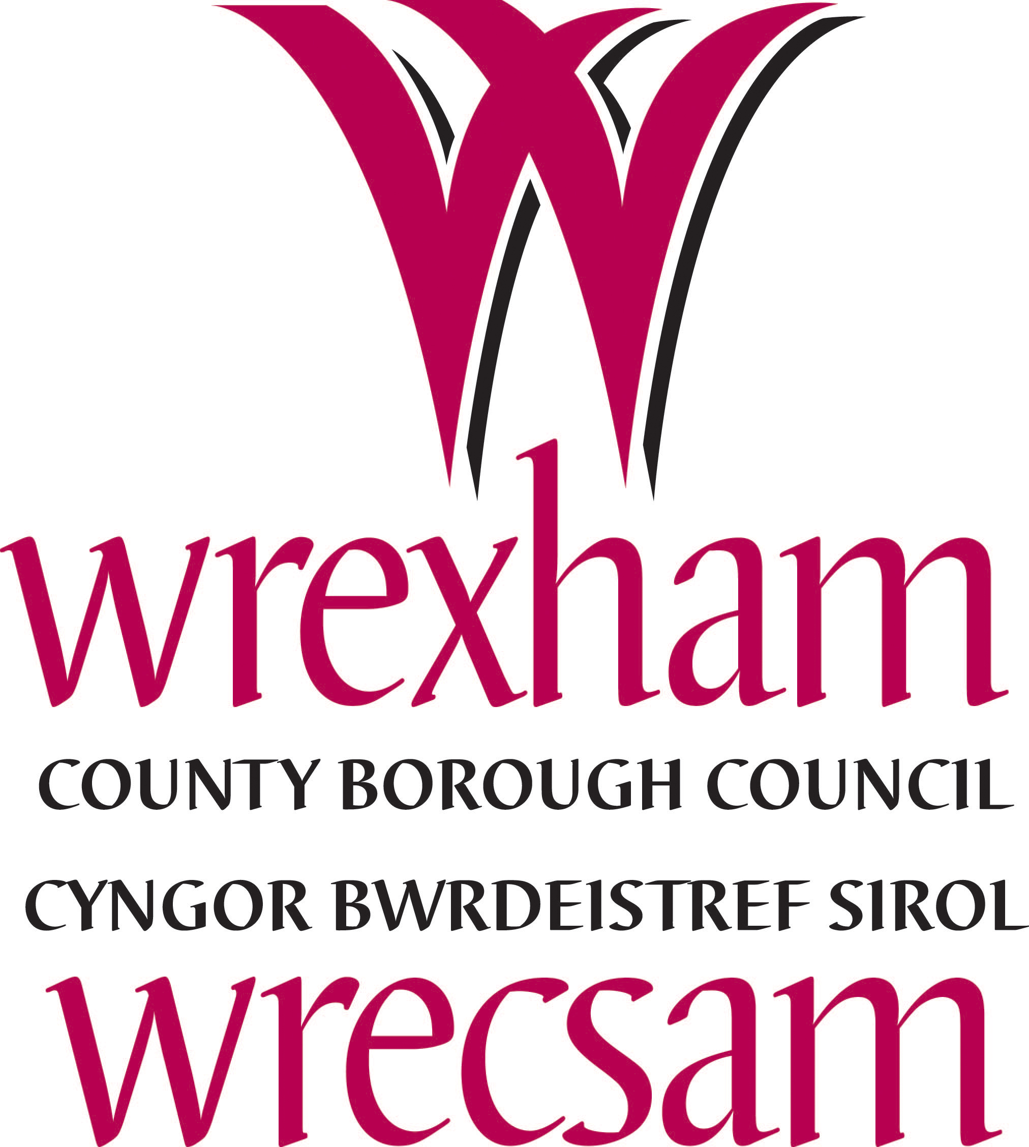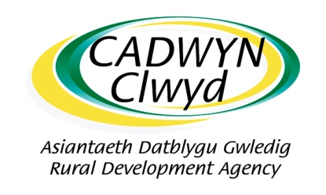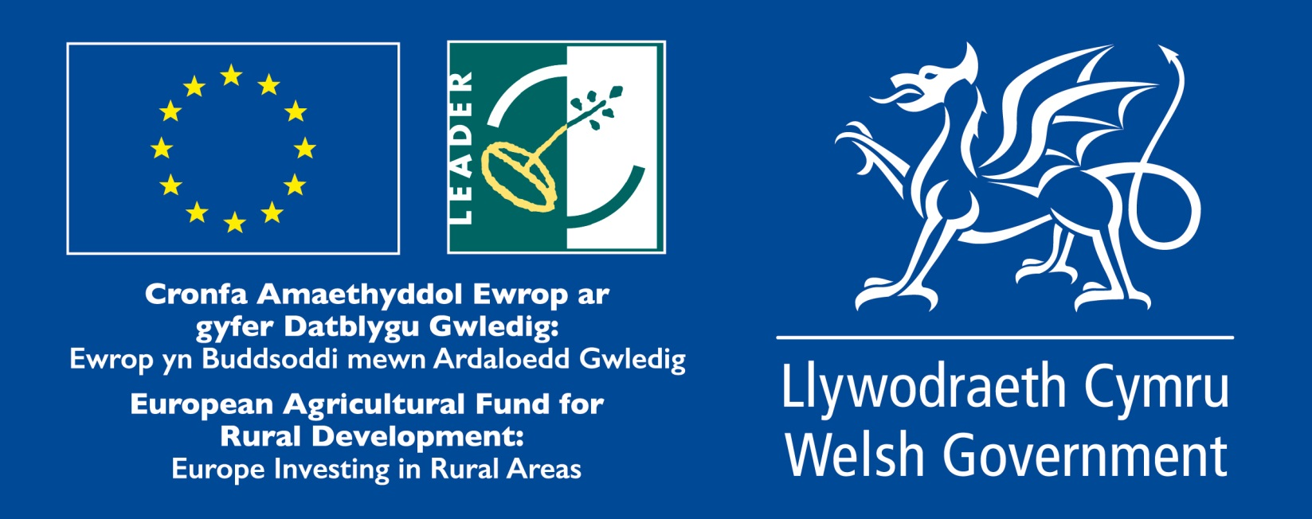

Cadwyn Clwyd takes the protection of your personal information very seriously and will process it in accordance with the UK Data Protection Act 1998 and its Data Protection Policy. In providing this information, you agree that it may be shared with the other bodies for the purpose of EU, Welsh Government and Cadwyn Clwyd funded project administration, monitoring, research and evaluation

